- Modifier : Modifiers fall into two categories:
- Access modifiers: public, protected, private.
- Non-access modifiers : including strictfp, final, and abstract.

Protected and Default Members : The protected and default access control levels are almost identical, but with one critical difference. A default member may be accessed only if the class accessing the member belongs to the same package, whereas a protected member can be accessed(through inheritance) by a subclass even if the subclass is in a different package.
strictfp : Marking a class as strictfp means that any method code in the class will conform to the IEEE 754 standard rules for floating points. Without that modifier, floating points used in the methods might behave in a platform-dependent way.
final: When used in a class declaration, the final keyword means the class can't be subclassed. In other words, no other class can ever extend (inherit from) a final class, and any attempts to do so will give you a compiler error.
abstract: An abstract class can never be instantiated. Its sole purpose, mission in life, raison d'être, is to be extended.
Why make a class if you can't make objects out of it? Because the class might be just too, well, abstract. For example, imagine you have a class Car that has generic methods common to all vehicles. But you don't want anyone actually creating a generic, abstract Car object. How would they initialize its state? What color would it be? How many seats? Horsepower? All-wheel drive? Or more importantly, how would it behave? In other words, how would the methods be implemented?
No, you need programmers to instantiate actual car types such as BMWBoxster
and SubaruOutback.
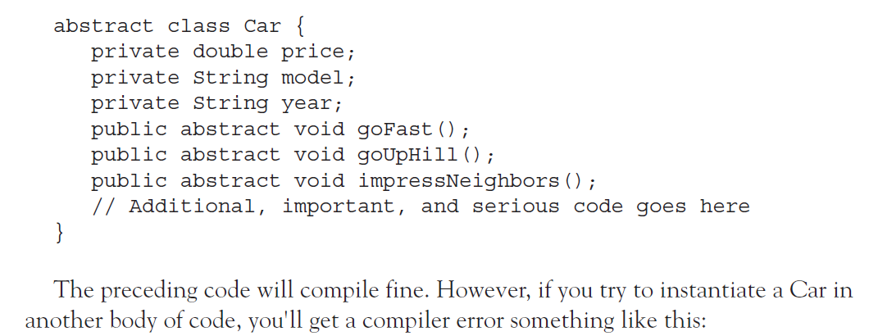
Q&A : Can access modifiers be applied to local variables? NO! only final can be used.
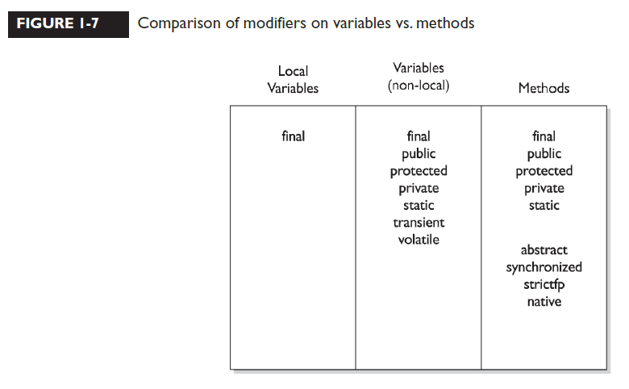
- Interface : When you create an interface, you're defining a contract for what a class can do,without saying anything about how the class will do it. An interface is a contract.You could write an interface Bounceable, for example, that says in effect, "This is the Bounceable interface. Any class type that implements this interface must agree to write the code for the bounce() and setBounceFactor() methods."
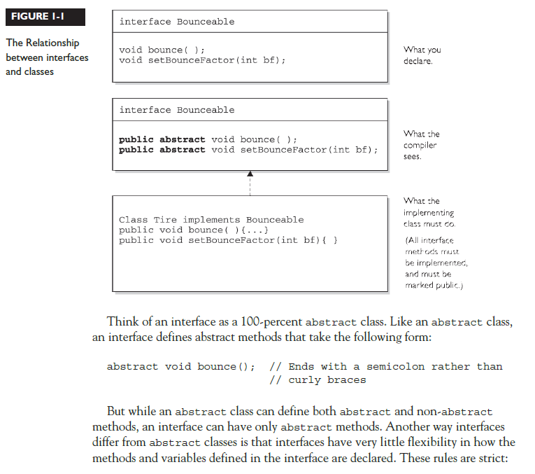
These rules are strict:
- All interface methods are implicitly public and abstract. In other words,
you do not need to actually type the public or abstract modifiers in the
method declaration, but the method is still always public and abstract.
- All variables defined in an interface must be public, static, and final—
in other words, interfaces can declare only constants, not instance variables.
- Interface methods must not be static.
- Because interface methods are abstract, they cannot be marked final,
strictfp, or native. (More on these modifiers later.)
- An interface can extend one or more other interfaces.
- An interface cannot extend anything but another interface.
- An interface cannot implement another interface or class.
- An interface must be declared with the keyword interface.
- Interface types can be used polymorphically (see Chapter 2 for more details).
Q&A : Interface vs Abstract ??
- Enum
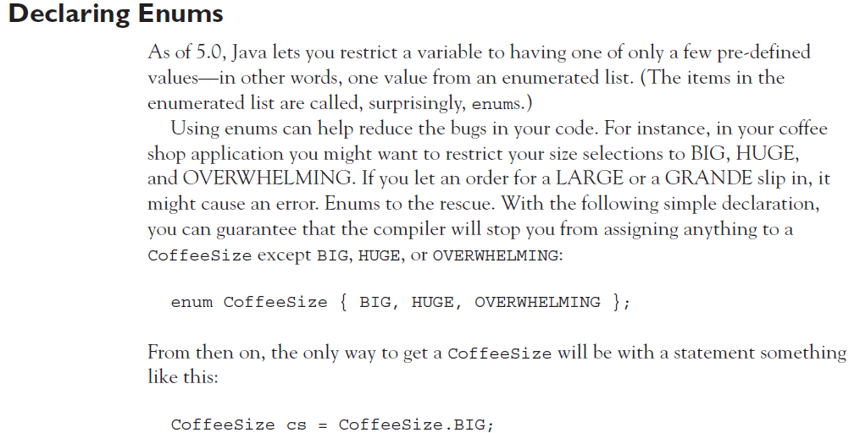

- H
- Polymorphism
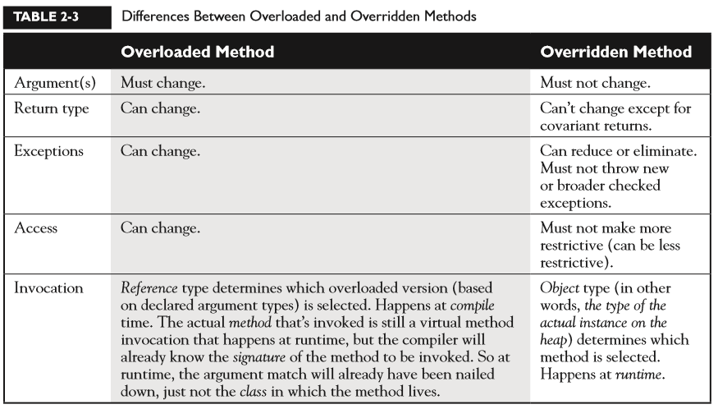
- Constructor Basics
Every class, including abstract classes, MUST have a constructor. Burn that into your brain. But just because a class must have one, doesn't mean the programmer has to type it. A constructor looks like this:
class Foo { Foo() { } // The constructor for the Foo class }
Notice what's missing? There's no return type! Two key points to remember about constructors are that they have no return type and their names must exactly match the class name
Constructor Chaining We know that constructors are invoked at runtime when you say new on some class type as follows:
Horse h = new Horse();
But what really happens when you say new Horse() ? (Assume Horse extends Animal and Animal extends Object
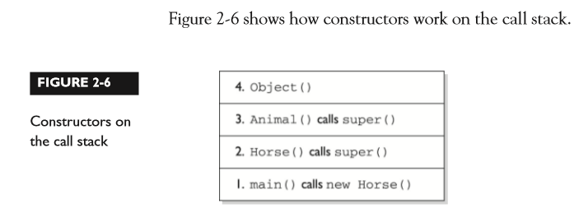
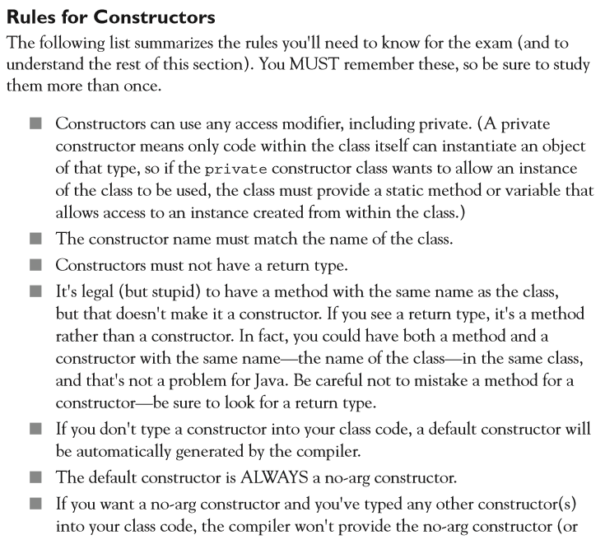
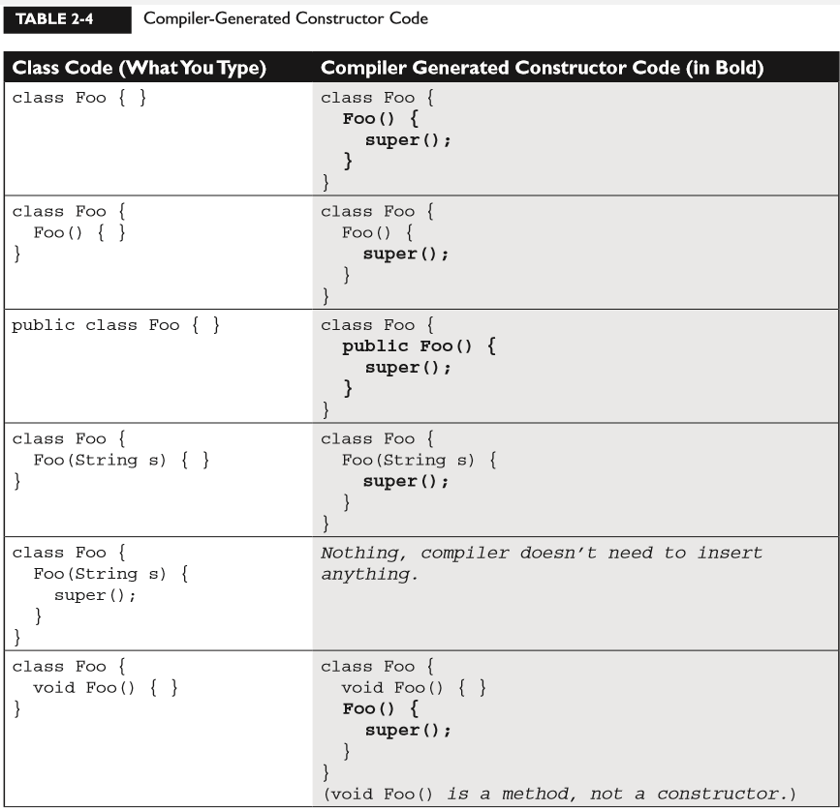
Static Variables and Methods
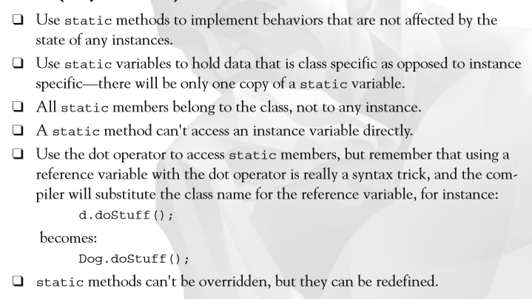
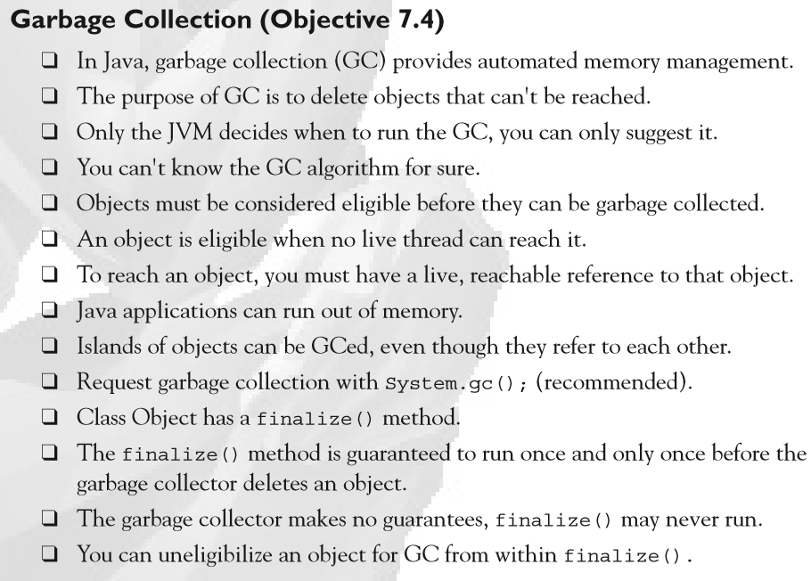

- Handling exceptions

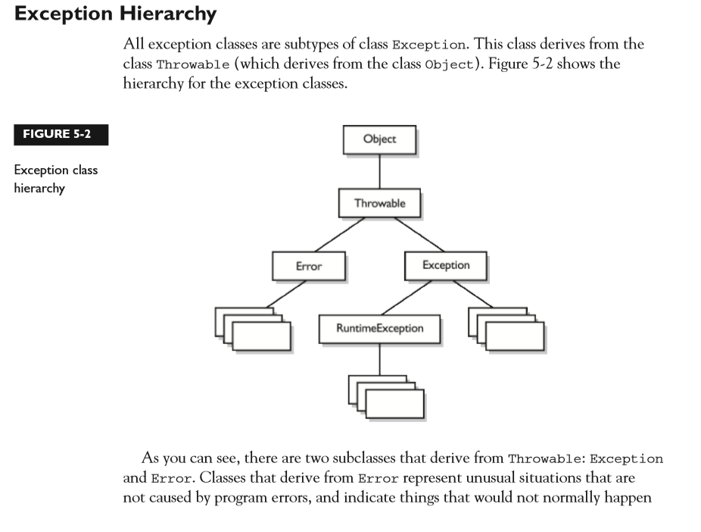
during program execution, such as the JVM running out of memory. Generally, your application won't be able to recover from an Error, so you're not required to handle them. If your code does not handle them (and it usually won't), it will still compile with no trouble. Although often thought of as exceptional conditions, Errors are technically not exceptions because they do not derive from class Exception.

Exception Matching : If you have an exception hierarchy composed of a superclass exception and a number of subtypes, and you're interested in handling one of the subtypes in a special way but want to handle all the rest together, you need write only two catch clauses. When an exception is thrown, Java will try to find (by looking at the available catch clauses from the top down) a catch clause for the exception type. If it doesn't find one, it will search for a handler for a supertype of the exception. If it does not find a catch clause that matches a supertype for the exception, then the exception is propagated down the call stack. This process is called exception matching.
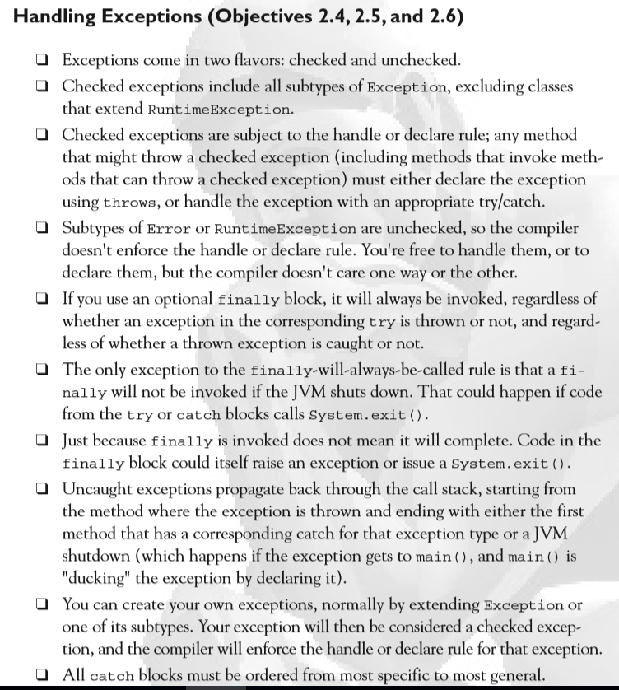

- Singleton class in java

This is a class which can be instatiated only once per JVM.

Eg:

Public class Singleton
{
private static single = new Singleton();

Private Singleton();
{}
}

For a singleton class, the constructor is made private and
a static variable is used for instatiating the class.

////////////////////////////////////////////////////////////////////////////////////////////////////////////

A Singleton is a class which at any given time has only one
instance and it does not allow more instances to be created.
Such classes do not have an accessible constructor, for example:

public class Singleton {
// class is automatically instantiated when the
// class is loaded
private static Singleton instance = new Singleton()

// constructor is made inaccessible by declaring
// it private
private Singleton() { ... }

// Access to the single instance of the class is
// provided by a static accessor method
public static Singleton getInstance() {
// returns a reference of the private instance
return instance;
}

// rest of the class implementation
}

Read more: https://javarevisited.blogspot.com/2011/03/10-interview-questions-on-singleton.html#ixzz5iDdgGzbL

When is Singleton not a Singleton in Java?
There is a very good article present in Sun's Java site which discusses various scenarios when a Singleton is not really remains Singleton and multiple instance of Singleton is possible. Here is the link of that article http://java.sun.com/developer/technicalArticles/Programming/singletons/

Multiple singletons in two or more virtual machines

Multiple singletons simultaneously loaded by different class loaders

Copies of a singleton object that has undergone serialization and deserialization

- What are different types of inner classes?

Nested top-level classes- If you declare a class within a class and specify the static modifier, the compiler treats the class just like any other top-level class.
Any class outside the declaring class accesses the nested class with the declaring class name acting similarly to a package. eg, outer.inner. Top-level inner classes implicitly have access only to static variables.There can also be inner interfaces. All of these are of the nested top-level variety

Member classes - Member inner classes are just like other member methods and member variables and access to the member class is restricted, just like methods and variables. This means a public member class acts similarly to a nested top-level class. The primary difference between member classes and nested top-level classes is that member classes have access to the specific instance of the enclosing class.

Local classes - Local classes are like local variables, specific to a block of code. Their visibility is only within the block of their declaration. In order for the class to be useful beyond the declaration block, it would need to implement a
more publicly available interface.Because local classes are not members, the modifiers public, protected, private, and static are not usable.

Anonymous classes - Anonymous inner classes extend local inner classes one level further. As anonymous classes have no name, you cannot provide a constructor

- How can I customize the seralization process? i.e. how can one have a control over the serialization process?

Yes it is possible to have control over serialization process. The class should implement Externalizable interface. This interface contains two methods namely readExternal and writeExternal. You should implement these methods and write the logic for customizing the serialization process.

- When you serialize an object, what happens to the object references included in the object?

The serialization mechanism generates an object graph for serialization. Thus it determines whether the included object references are serializable or not. This is a recursive process. Thus when an object is serialized, all the included objects are also serialized alongwith the original obect.

- What happens to the static fields of a class during serialization?

There are three exceptions in which serialization doesnot necessarily read and write to the stream. These are
1. Serialization ignores static fields, because they are not part of any particular state state.
2. Base class fields are only handled if the base class itself is serializable.
3. Transient fields.

- What are the steps in the JDBC connection?

Step 1 : Register the database driver by using :
Class.forName(\" driver classs for that specific database\" );
Step 2 : Now create a database connection using :
Connection con = DriverManager.getConnection(url,username,password);
Step 3: Now Create a query using :
Statement stmt = Connection.Statement(\"select * from TABLE NAME\");
Step 4 : Exceute the query :
stmt.exceuteUpdate();
- What are some alternatives to inheritance?

Delegation is an alternative to inheritance. Delegation means that you include an instance of another class as an instance variable, and forward messages to the instance. It is often safer than inheritance because it forces you to think about each message you forward, because the instance is of a known class, rather than a new class, and because it doesn't force you to accept all the methods of the super class: you can provide only the methods that really make sense. On the other hand, it makes you write more code, and it is harder to re-use (because it is not a subclass).

Delegation is simply passing a duty off to someone/something else. Here is a simple example:

Code:
public class Information
{
public String getTemperature()
{
return TempGetter.getTemperature();
}

public String getTime()
{
return TimeGetter.getTime();
}
}

In this example, I've got imaginary classes TimeGetter and TempGetter that have static methods for retrieving time and temperature. Rather than finding my own way to obtain these data, I use existing classes. Said another way, I delegate these tasks to these classes without knowing/caring about the details of how it gets done.
- Rule for declaring an interface

These rules are strict:

- All interface methods are implicitly public and abstract. In other words,
you do not need to actually type the public or abstract modifiers in the
method declaration, but the method is still always public and abstract.

- All variables defined in an interface must be public, static, and final—
- in other words, interfaces can declare only constants, not instance variables.

- Interface methods must not be static.

- Because interface methods are abstract, they cannot be marked final,
- strictfp, or native. (More on these modifiers later.)

- An interface can extend one or more other interfaces.

- An interface cannot extend anything but another interface.

- An interface cannot implement another interface or class.

- An interface must be declared with the keyword interface.

- Interface types can be used polymorphically (see Chapter 2 for more details).

The following is a legal interface declaration:

public abstract interface Rollable { }

Typing in the abstract modifier is considered redundant; interfaces are
implicitly abstract whether you type abstract or not. You just need to know that
both of these declarations are legal, and functionally identical:

public abstract interface Rollable { }
public interface Rollable { }

- Protected Details :-

  - Subclass outside the package can't use a superclass reference to access a protected member.

  - For a subclass outside the package, the protected member can be accessed only
through inheritance.

  - when a subclass-outside-the-package inherits
a protected member, the member is essentially private inside the subclass, such that only the subclass and its subclasses can access it.

  - Default and protected behavior differ only when we talk about subclasses. If the protected keyword is used to define a member, any subclass of the class declaring the member can access it through inheritance. It doesn't matter if the superclass and subclass are in different packages, the protected superclass member is still visible to
the subclass (although visible only in a very specific way as we'll see a little later). This is in contrast to the default behavior, which doesn't allow a subclass to access a superclass member unless the subclass is in the same package as the superclass.

  - there is only one modifier that can ever be applied to local
variables—final.

  - You can, have an abstract class with no abstract methods.

- Methods with Variable Argument Lists (var-args)

  - Arguments: The things you specify between the parentheses when you're invoking a method:

doStuff("a", 2); // invoking doStuff, so a & 2 are arguments

  - Parameters: The things in the method's signature that indicate what the method must receive when it's invoked:

void doStuff(String s, int a) { } // we're expecting two
// parameters: String and int

The declaration rules for var-args:

  - Var-arg type When you declare a var-arg parameter, you must specify the type of the argument(s) this parameter of your method can receive. (This can be a primitive type or an object type.)
  - Basic syntax To declare a method using a var-arg parameter, you follow the type with an ellipsis (...), a space, and then the name of the array that will hold the parameters received.
  - Other parameters It's legal to have other parameters in a method that uses a var-arg.
  - Var-args limits The var-arg must be the last parameter in the method's

signature, and you can have only one var-arg in a method.
Let's look at some legal and illegal var-arg declarations:
Legal:

void doStuff(int... x) { } // expects from 0 to many ints
// as parameters
void doStuff2(char c, int... x) { } // expects first a char,
// then 0 to many ints
void doStuff3(Animal... animal) { } // 0 to many Animals

- Constructor Declarations

  - constructor can't ever, ever, ever, have a return type…ever!

Constructors can't be marked static (they
are after all associated with object instantiation), they can't be marked final or abstract (because they can't be overridden). Here are some legal and illegal constructor declarations:
class Foo2 {

// legal constructors

Foo2() { }

private Foo2(byte b) { }
Foo2(int x) { }
Foo2(int x, int... y) { }

// illegal constructors

void Foo2() { } // it's a method, not a constructor
Foo() { } // not a method or a constructor
Foo2(short s); // looks like an abstract method
static Foo2(float f) { } // can't be static
final Foo2(long x) { } // can't be final
abstract Foo2(char c) { } // can't be abstract
Foo2(int... x, int t) { } // bad var-arg syntax
}

- Comparison of modifiers on variables vs. methods
LOCAL VAR INSTANCE VAR METHODS

Transient Variables

If you mark an instance variable as transient, you're telling the JVM to skip
(ignore) this variable when you attempt to serialize the object containing it.
Serialization is one of the coolest features of Java; it lets you save (sometimes called
"flatten") an object by writing its state (in other words, the value of its instance
variables) to a special type of I/O stream. With serialization you can save an object
to a file, or even ship it over a wire for reinflating (deserializing) at the other end, in
another JVM. Serialization has been added to the exam as of Java 5,

Volatile Variables
The volatile modifier tells the JVM that a thread accessing the variable must
always reconcile its own private copy of the variable with the master copy in
memory. Say what? Don't worry about it. For the exam, all you need to know about
volatile is that, as with transient, it can be applied only to instance variables.
Make no mistake, the idea of multiple threads accessing an instance variable is scary
stuff, and very important for any Java programmer to understand. you'll probably use synchronization, rather than the volatile modifier,
to make your data thread-safe.

Static Variables and Methods

The static modifier is used to create variables and methods that will exist
independently of any instances created for the class. In other words, static
members exist before you ever make a new instance of a class, and there will be
only one copy of the static member regardless of the number of instances of that
class. In other words, all instances of a given class share the same value for any given
static variable. We'll cover static members in great detail in the next chapter.

Things you can mark as static:

- Methods
- Variables
- A class nested within another class, but not within a method
- Initialization blocks

Things you can't mark as static:

- Constructors (makes no sense; a constructor is used only to create instances)
- Classes (unless they are nested)
- Interfaces
- Method local inner classes
- Inner class methods and instance variables
- Local variables

13) DownCasting and UpCasting

class Animal {
void makeNoise() {System.out.println("generic noise"); }
}
class Dog extends Animal {
void makeNoise() {System.out.println("bark"); }
void playDead() { System.out.println(" roll over"); }
}
class CastTest2 {
public static void main(String [] args) {
Animal [] a = {new Animal(), new Dog(), new Animal() };
for(Animal animal : a) {
animal.makeNoise();
if(animal instanceof Dog) {
animal.playDead(); // try to do a Dog behavior ?
}
}
}
}

When we try to compile this code, the compiler says something like this:
cannot find symbol

The compiler is saying, "Hey, class Animal doesn't have a playDead() method".
Let's modify the if code block:

if(animal instanceof Dog) {
Dog d = (Dog) animal; // casting the ref. var.
d.playDead();
}

The new and improved code block contains a cast, which in this case is
sometimes called a downcast, because we're casting down the inheritance tree to a more specific class. Now, the compiler is happy. Before we try to invoke playDead,
we cast the animal variable to type Dog. What we're saying to the compiler is, "We
know it's really referring to a Dog object, so it's okay to make a new Dog reference
variable to refer to that object." In this case we're safe because before we ever try the

cast, we do an instanceof test to make sure.
It's important to know that the compiler is forced to trust us when we do a
downcast, even when we screw up:

class Animal { }
class Dog extends Animal { }
class DogTest {
public static void main(String [] args) {
Animal animal = new Animal();
Dog d = (Dog) animal; // compiles but fails later
}
}

It can be maddening! This code compiles! When we try to run it, we'll get an
exception something like this:
java.lang.ClassCastException
Why can't we trust the compiler to help us out here? Can't it see that animal
is of type Animal? All the compiler can do is verify that the two types are in the
same inheritance tree, so that depending on whatever code might have come before
the downcast, it's possible that animal is of type Dog. The compiler must allow

things that might possibly work at runtime. However, if the compiler knows with
certainty that the cast could not possibly work, compilation will fail. The following
replacement code block will NOT compile:

Animal animal = new Animal();
Dog d = (Dog) animal;
String s = (String) animal; // animal can't EVER be a String

In this case, you'll get an error something like this:
inconvertible types

Unlike downcasting, upcasting (casting up the inheritance tree to a more general type) works implicitly (i.e. you don't have to type in the cast) because when you upcast you're implicitly restricting the number of methods you can invoke, as opposed to downcasting, which implies that later on, you might want to invoke a
more specific method. For instance:

class Animal { }
class Dog extends Animal { }
class DogTest {
public static void main(String [] args) {
Dog d = new Dog();
Animal a1 = d; // upcast ok with no explicit cast
Animal a2 = (Animal) d; // upcast ok with an explicit cast
}
}

Both of the previous upcasts will compile and run without exception, because a
Dog IS-A Animal, which means that anything an Animal can do, a Dog can do. A
Dog can do more, of course, but the point is—anyone with an Animal reference can
safely call Animal methods on a Dog instance. The Animal methods may have been
overridden in the Dog class, but all we care about now is that a Dog can always do
at least everything an Animal can do. The compiler and JVM know it too, so the
implicit upcast is always legal for assigning an object of a subtype to a reference of
one of its supertype classes (or interfaces). If Dog implements Pet, and Pet defines
beFriendly(), then a Dog can be implicitly cast to a Pet, but the only Dog method
you can invoke then is beFriendly(), which Dog was forced to implement because
Dog implements the Pet interface.

One more thing…if Dog implements Pet, then if Beagle extends Dog, but
Beagle does not declare that it implements Pet, Beagle is still a Pet! Beagle is a Pet
simply because it extends Dog, and Dog's already taken care of the Pet parts of itself,
and all its children. The Beagle class can always override any methods it inherits
from Dog, including methods that Dog implemented to fulfill its interface contract.
And just one more thing…if Beagle does declare it implements Pet, just so that
others looking at the Beagle class API can easily see that Beagle IS-A Pet, without
having to look at Beagle's superclasses, Beagle still doesn't need to implement the
beFriendly() method if the Dog class (Beagle's superclass) has already taken care of
that. In other words, if Beagle IS-A Dog, and Dog IS-A Pet, then Beagle IS-A Pet,
and has already met its Pet obligations for implementing the beFriendly() method
since it inherits the beFriendly() method. The compiler is smart enough to say, "I
know Beagle already IS a Dog, but it's OK to make it more obvious."
So don't be fooled by code that shows a concrete class that declares that it
implements an interface, but doesn't implement the methods of the interface. Before
you can tell whether the code is legal, you must know what the superclasses of this
implementing class have declared. If any class in its inheritance tree has already
provided concrete (i.e., non-abstract) method implementations, and has declared
that it (the superclass) implements the interface, then the subclass is under no
obligation to re-implement (override) those methods.

14) Tips

One of the mistakes most often made by new Java programmers is
attempting to access an instance variable (which means nonstatic variable) from the
static main() method (which doesn’t know anything about any instances, so it can’t
access the variable). The following code is an example of illegal access of a nonstatic
variable from a static method:
class Foo {
int x = 3;
public static void main (String [] args) {
System.out.println("x is " + x);
} }
Understand that this code will never compile, because you can’t access
a nonstatic (instance) variable from a static method. Just think of the compiler saying,
“Hey, I have no idea which Foo object’s x variable you’re trying to print!” Remember, it’s
the class running the main() method, not an instance of the class.

15) Stack and Heap

For the most part, the various pieces (methods, variables, and objects) of Java
programs live in one of two places in memory: the stack or the heap. For now, we're
going to worry about only three types of things: instance variables, local variables,
and objects:
- Instance variables and objects live on the heap.
- Local variables live on the stack.
Let's take a look at a Java program, and how its various pieces are created and
map into the stack and the heap:

1. class Collar { }
2.
3. class Dog {
4. Collar c; // instance variable
5. String name; // instance variable
6.
7. public static void main(String [] args) {
8.
9. Dog d; // local variable: d
10. d = new Dog();
11. d.go(d);
12. }
13. void go(Dog dog) { // local variable: dog
14. c = new Collar();
15. dog.setName("Fido");
16. }
17. void setName(String dogName) { // local var: dogName
18. name = dogName;
19. // do more stuff
20. }
21. }
Figure 3-1 shows the state of the stack and the heap once the program reaches
line 19. Following are some key points:

Line 7—main() is placed on the stack.
Line 9—reference variable d is created on the stack, but there's no Dog
object yet.
Line 10—a new Dog object is created and is assigned to the d reference
variable.
Line 11—a copy of the reference variable d is passed to the go() method.
Line 13—the go() method is placed on the stack, with the dog parameter as
a local variable.
Line 14—a new Collar object is created on the heap, and assigned to Dog's
instance variable.
Line 17—setName() is added to the stack, with the dogName parameter as
its local variable.
Line 18—the name instance variable now also refers to the String object.
Notice that two different local variables refer to the same Dog object.
Notice that one local variable and one instance variable both refer to the
same String Aiko.
After Line 19 completes, setName() completes and is removed from the
stack. At this point the local variable dogName disappears too, although the
String object it referred to is still on the heap.

16) Boxing, ==, and equals()

We just used == to do a little exploration of wrappers. Let's take a more thorough
look at how wrappers work with ==, !=, and equals(). We'll talk a lot more about
the equals() method in later chapters. For now all we have to know is that the
intention of the equals() method is to determine whether two instances of a given
class are "meaningfully equivalent." This definition is intentionally subjective; it's
up to the creator of the class to determine what "equivalent" means for objects of the
class in question. The API developers decided that for all the wrapper classes, two
objects are equal if they are of the same type and have the same value. It shouldn't
be surprising that
Integer i1 = 1000;
Integer i2 = 1000;
if(i1 != i2) System.out.println("different objects");
if(i1.equals(i2)) System.out.println("meaningfully equal");
Produces the output:
different objects
meaningfully equal
It's just two wrapper objects that happen to have the same value. Because they
have the same int value, the equals() method considers them to be "meaningfully
equivalent", and therefore returns true. How about this one:
Integer i3 = 10;
Integer i4 = 10;
if(i3 == i4) System.out.println("same object");
if(i3.equals(i4)) System.out.println("meaningfully equal");
This example produces the output:
same object
meaningfully equal
Yikes! The equals() method seems to be working, but what happened with ==
and != ? Why is != telling us that i1 and i2 are different objects, when == is saying
that i3 and i4 are the same object? In order to save memory, two instances of the

following wrapper objects will always be == when their primitive values are the same:
Boolean
Byte
Character from \u0000 to \u007f (7f is 127 in decimal)
Short and Integer from -128 to 127

17) Static Imports

We've been using import statements throughout the book. Ultimately, the only
value import statements have is that they save typing and they can make your code
easier to read. In Java 5, the import statement was enhanced to provide even greater
keystroke-reduction capabilities…although some would argue that this comes at the
expense of readability. This new feature is known as static imports. Static imports can
be used when you want to use a class's static members. (You can use this feature on
classes in the API and on your own classes.) Here's a "before and after" example:
Before static imports:
public class TestStatic {
public static void main(String[] args) {
System.out.println(Integer.MAX_VALUE);
System.out.println(Integer.toHexString(42));
}
}
After static imports:
import static java.lang.System.out; // 1
import static java.lang.Integer.*; // 2
public class TestStaticImport {
public static void main(String[] args) {
out.println(MAX_VALUE); // 3
out.println(toHexString(42)); // 4
}
}
Both classes produce the same output:
2147483647
2a
Let's look at what's happening in the code that's using the static import feature:

1. Even though the feature is commonly called "static import" the syntax MUST
be import static followed by the fully qualified name of the static member
you want to import, or a wildcard. In this case we're doing a static import on the
System class's out object.
2. In this case we might want to use several of the static members of the
java.lang.Integer class. This static import statement uses the wildcard to say
"I want to do static imports of ALL the static members in this class."
3. Now we're finally seeing the benefit of the static import feature! We didn't have to
type the System in System.out.println! Wow! Second, we didn't have to type
the Integer in Integer.MAX_VALUE. So in this line of code we were able to use
a shortcut for a static method AND a constant.
4. Finally, we do one more shortcut, this time for a method in the Integer class.
We've been a little sarcastic about this feature, but we're not the only ones. We're
not convinced that saving a few keystrokes is worth possibly making the code a little
harder to read, but enough developers requested it that it was added to the language.
Here are a couple of rules for using static imports:
n You must say import static; you can't say static import.
n Watch out for ambiguously named static members. For instance, if you do
a static import for both the Integer class and the Long class, referring to
MAX_VALUE will cause a compiler error, since both Integer and Long have
a MAX_VALUE constant, and Java won't know which MAX_VALUE you're referring
to.
n You can do a static import on static object references, constants (remember
they're static and final), and static methods.

18 ) Distinguish between correct and incorrect overrides of corresponding hashCode and equals methods, and explain the difference between == and the equals method.

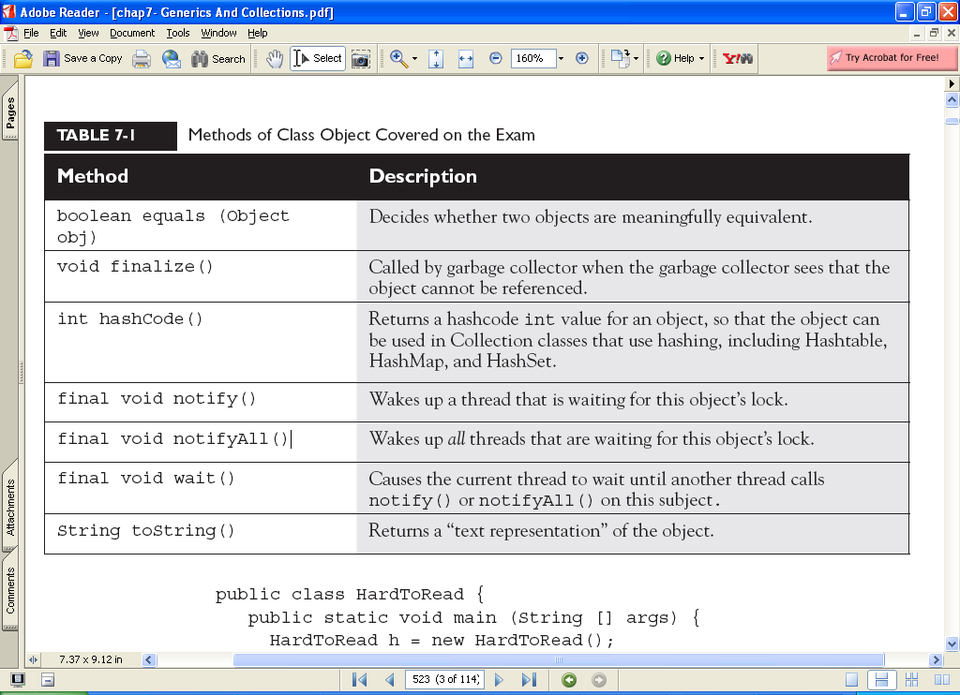

public class HardToRead {
public static void main (String [] args) {
HardToRead h = new HardToRead();
System.out.println(h);
}
}
Running the HardToRead class gives us the lovely and meaningful,
% java HardToRead
HardToRead@a47e0

The preceding output is what you get when you don't override the toString()
method of class Object. It gives you the class name (at least that's meaningful)
followed by the @ symbol, followed by the unsigned hexadecimal representation of
the object's hashcode.
Trying to read this output might motivate you to override the toString()
method in your classes.
Overriding equals()

The equals() method in class Object uses only the == operator for comparisons,
so unless you override equals(), two objects are considered equal only if the two
references refer to the same object.
Let's look at what it means to not be able to use an object as a hashtable key.
Imagine you have a car, a very specific car (say, John's red Subaru Outback as
opposed to Mary's purple Mini) that you want to put in a HashMap (a type of
hashtable we'll look at later in this chapter), so that you can search on a particular
car and retrieve the corresponding Person object that represents the owner. So you
add the car instance as the key to the HashMap (along with a corresponding Person
object as the value). But now what happens when you want to do a search? You want
to say to the HashMap collection, "Here's the car, now give me the Person object
that goes with this car." But now you're in trouble unless you still have a reference
to the exact object you used as the key when you added it to the Collection. In other
words, you can't make an identical Car object and use it for the search.
The bottom line is this: if you want objects of your class to be used as keys for a
hashtable (or as elements in any data structure that uses equivalency for searching
for—and/or retrieving—an object), then you must override equals() so that two
different instances can be considered the same. So how would we fix the car? You
might override the equals() method so that it compares the unique VIN (Vehicle
Identification Number) as the basis of comparison. That way, you can use one
instance when you add it to a Collection, and essentially re-create an identical
instance when you want to do a search based on that object as the key. Of course,
overriding the equals() method for Car also allows the potential that more than
one object representing a single unique car can exist, which might not be safe

The equals() Contract

Pulled straight from the Java docs, the equals() contract says

It is reflexive. For any reference value x, x.equals(x) should return true.

It is symmetric. For any reference values x and y, x.equals(y) should
return true if and only if y.equals(x) returns true.

It is transitive. For any reference values x, y, and z, if x.equals(y) returns
true and y.equals(z) returns true, then x.equals(z) must return true.

It is consistent. For any reference values x and y, multiple invocations of
x.equals(y) consistently return true or consistently return false, provided
no information used in equals comparisons on the object is modified.

For any non-null reference value x, x.equals(null) should return false.

And you're so not off the hook yet. We haven't looked at the hashCode()
method, but equals() and hashCode() are bound together by a joint contract that
specifies if two objects are considered equal using the equals() method, then they
must have identical hashcode values. So to be truly safe, your rule of thumb should
be, if you override equals(), override hashCode() as well. So let's switch over to
hashCode() and see how that method ties in to equals().

Overriding hashCode()

Hashcodes are typically used to increase the performance of large collections of
data. The hashcode value of an object is used by some collection classes (we'll look

at the collections later in this chapter). Although you can think of it as kind of an
object ID number, it isn't necessarily unique. Collections such as HashMap and
HashSet use the hashcode value of an object to determine how the object should
be stored in the collection, and the hashcode is used again to help locate the object
in the collection. For the exam you do not need to understand the deep details of
how the collection classes that use hashing are implemented, but you do need to
know which collections use them (but, um, they all have "hash" in the name so
you should be good there). You must also be able to recognize an appropriate or
correct implementation of hashCode(). This does not mean legal and does not even
mean efficient. It's perfectly legal to have a terribly inefficient hashcode method
in your class, as long as it doesn't violate the contract specified in the Object class
documentation (we'll look at that contract in a moment). So for the exam, if you're
asked to pick out an appropriate or correct use of hashcode, don't mistake appropriate for legal or efficient.

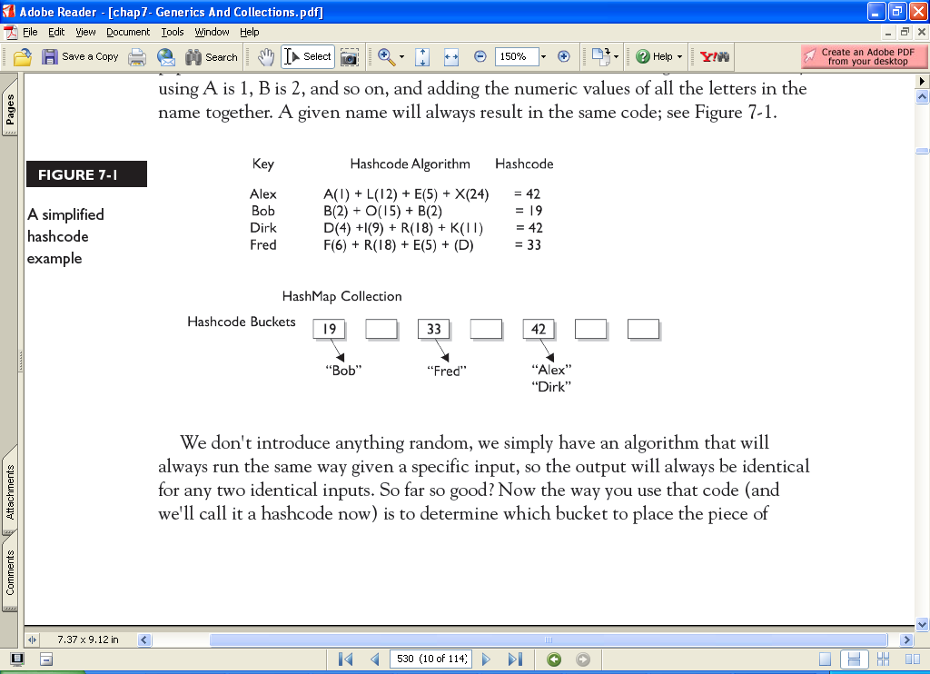
Now can you see why if two objects are considered equal, their hashcodes must
also be equal? Otherwise, you'd never be able to find the object since the default
hashcode method in class Object virtually always comes up with a unique number
for each object, even if the equals() method is overridden in such a way that two
or more objects are considered equal. It doesn't matter how equal the objects are if
their hashcodes don't reflect that. So one more time: If two objects are equal, their
hashcodes must be equal as well.

Implementing hashCode()

What the heck does a real hashcode algorithm look like? People get their PhDs on
hashing algorithms, so from a computer science viewpoint, it's beyond the scope
of the exam. The part we care about here is the issue of whether you follow the
contract. And to follow the contract, think about what you do in the equals()
method. You compare attributes. Because that comparison almost always involves
instance variable values (remember when we looked at two Moof objects and
considered them equal if their int moofValues were the same?). Your hashCode()
implementation should use the same instance variables. Here's an example:

class HasHash {
public int x;
HasHash(int xVal) { x = xVal; }
public boolean equals(Object o) {
HasHash h = (HasHash) o; // Don't try at home without
// instanceof test
if (h.x == this.x) {
return true;
} else {
return false;
}

}
public int hashCode() { return (x * 17); }
}

This equals() method says two objects are equal if they have the same x value,
so objects with the same x value will have to return identical hashcodes.

The hashCode() Contract

Now coming to you straight from the fabulous Java API documentation for class
Object, may we present (drum roll) the hashCode() contract:

Whenever it is invoked on the same object more than once during an execution
of a Java application, the hashCode() method must consistently return
the same integer, provided no information used in equals() comparisons
on the object is modified. This integer need not remain consistent from one
execution of an application to another execution of the same application.

If two objects are equal according to the equals(Object) method, then
calling the hashCode() method on each of the two objects must produce the
same integer result.

It is NOT required that if two objects are unequal according to the
equals(java.lang.Object) method, then calling the hashCode() method
on each of the two objects must produce distinct integer results. However,
the programmer should be aware that producing distinct integer results for
unequal objects may improve the performance of hashtables.

19 ) Collections

The Collections Framework in Java, which took shape with the release of
JDK 1.2 and was expanded in 1.4 and again in Java 5, gives you lists, sets, maps,
and queues to satisfy most of your coding needs. They've been tried, tested, and
tweaked. Pick the best one for your job and you'll get—at the least—reasonable
performance. And when you need something a little more custom, the Collections
Framework in the java.util package is loaded with interfaces and utilities.

What Do You Do with a Collection?

There are a few basic operations you'll normally use with collections:
Add objects to the collection.
after another.Remove objects from the collection.
Find out if an object (or group of objects) is in the collection.
Retrieve an object from the collection (without removing it).
Iterate
through the collection, looking at each element (object) one

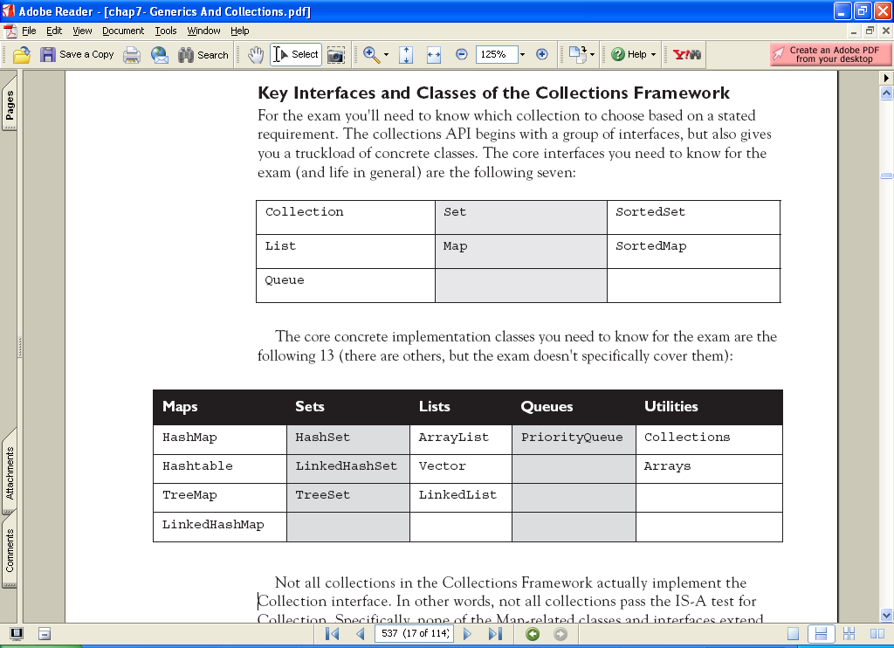
Not all collections in the Collections Framework actually implement the
Collection interface. In other words, not all collections pass the IS-A test for
Collection. Specifically, none of the Map-related classes and interfaces extend
from Collection. So while SortedMap, Hashtable, HashMap, TreeMap, and
LinkedHashMap are all thought of as collections, none are actually extended
from Collection-with-a-capital-C (see Figure 7-2). To make things a little more
confusing, there are really three overloaded uses of the word "collection":

collection (lowercase c), which represents any of the data structures in
which objects are stored and iterated over.

Collection (capital C), which is actually the java.util.Collection interface
from which Set, List, and Queue extend. (That's right, extend, not implement.
There are no direct implementations of Collection.)

Collections (capital C and ends with s) is the java.util.Collections class
that holds a pile of static utility methods for use with collections.

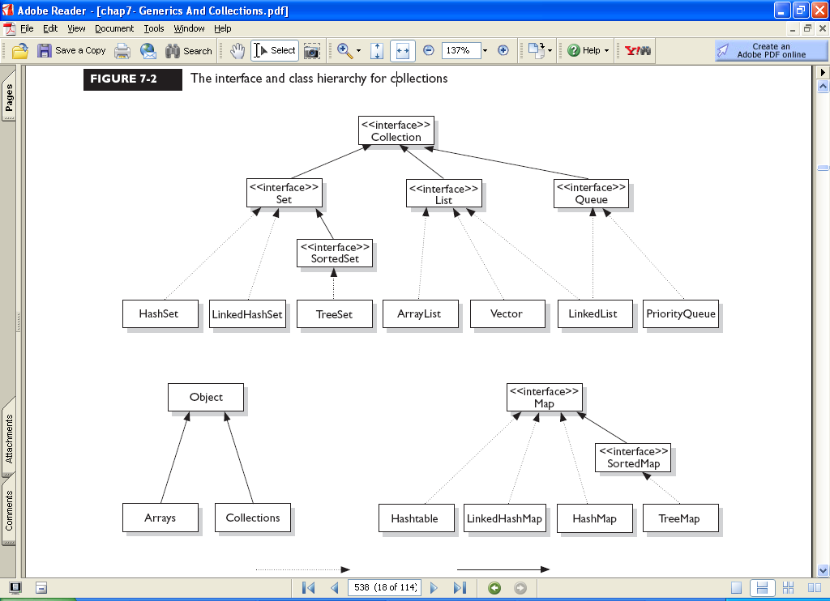

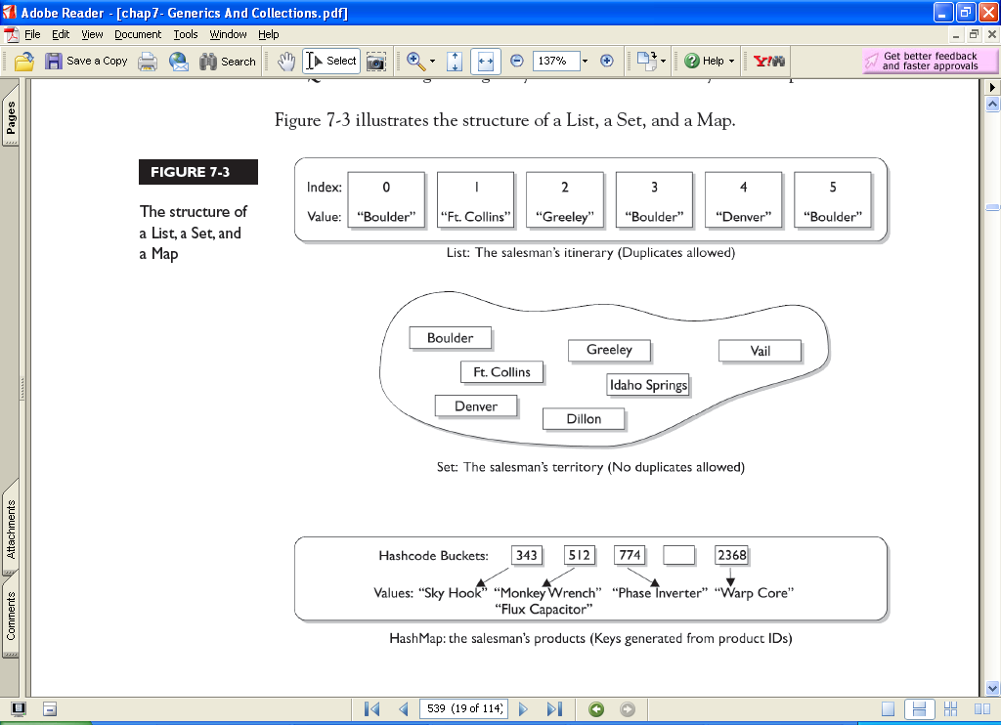

What is the difference between abstraction and encapsulation?

  - Abstraction focuses on the outside view of an object (i.e. the interface) Encapsulation(information hiding) prevents clients from seeing it?s inside view, where the behavior of the abstraction is implemented.
* Abstraction solves the problem in the design side while Encapsulation is the Implementation.
* Encapsulation is the deliverables of Abstraction. Encapsulation barely talks about grouping up your abstraction to suit the developer needs.

Super
super is a keyword which is used to access the method or member variables from the superclass. If a method hides one of the member variables in its superclass, the method can refer to the hidden variable through the use of the super keyword. In the same way, if a method overrides one of the methods in its superclass, the method can invoke the overridden method through the use of the super keyword.
Note:
* You can only go back one level.
* In the constructor, if you use super(), it must be the very first code, and you cannot access any this.xxx variables or methods to compute its parameters.

JVM

JVM is an abstract computing machine like any other real computing machine which interprets thebyte code( .class file which contains virtual machine instructions ) to a machine dependent native code. The output of JVM i.e the native code contains low level instructions which is easily understandable by the micro processors which process the native code to give the desire output.

JVM(Java virtual machine):it is the runtime environment for java programs and it contains the following :
1)class loader
2)byte code verifier
3)jit compiler and interpreter
java is a platform independent language which means it can be operated in any operating system
when you execute a program in C && C++ a .exe file is obtained which contains the source code
and operating system details where as when you execute a program in java a .class file is created which contains the byte code(source code) only.It is the JVM which links this byte code with the operating system details.
- There are four different ways (I really don’t know is there a fifth way to do this) to create objects in java:
1. Using new keyword
This is the most common way to create an object in java. I read somewhere that almost 99% of objects are created in this way.
MyObject object = new MyObject();
2. Using Class.forName()
If we know the name of the class & if it has a public default constructor we can create an object in this way.
MyObject object = (MyObject) Class.forName("subin.rnd.MyObject").newInstance();
3. Using clone()
The clone() can be used to create a copy of an existing object.
MyObject anotherObject = new MyObject();
MyObject object = anotherObject.clone();
4. Using object deserialization
Object deserialization is nothing but creating an object from its serialized form.
ObjectInputStream inStream = new ObjectInputStream(anInputStream );
MyObject object = (MyObject) inStream.readObject();

marker interface having no methods right.. then what is the use of marker interface? for what purpose we use marker interface?
One of the "clean" features of the Java programming language is that it mandates a separation between interfaces (pure behavior) and classes (state and behavior). Interfaces are used in Java to specify the behavior of derived classes.
Often you will come across interfaces in Java that have no behavior. In other words, they are just empty interface definitions. These are known as marker interfaces. Some examples of marker interfaces in the Java API include:
- java,lang.Cloneable
- java,io.Serializable
- java.util.EventListener
Marker interfaces are also called "tag" interfaces since they tag all the derived classes into a category based on their purpose. For example, all classes that implement the Cloneable interface can be cloned (i.e., the clone() method can be called on them). The Java compiler checks to make sure that if the clone() method is called on a class and the class implements the Cloneable interface. For example, consider the following call to the clone() method on an object o:
SomeObject o = new SomeObject();
SomeObject ref = (SomeObject)(o.clone());
If the class SomeObject does not implement the interface Cloneable (and Cloneable is not implemented by any of the superclasses that SomeObject inherits from), the compiler will mark this line as an error. This is because the clone() method may only be called by objects of type "Cloneable." Hence, even though Cloneable is an empty interface, it serves an important purpose.

20 Explain the usage of the keyword transient?
Answer: This keyword indicates that the value of this member variable does not have to be serialized with the object.When the class will be de-serialized, this variable will be initialized with a default value of its data type (i.e.zero for integers).
21 What's the difference between the methods sleep() and wait()
Answer: The code sleep(1000); puts thread aside for exactly one second.The code wait(1000), causes a wait of up to one second.A thread could stop waiting earlier if it receives the notify() or notifyAll() call.The method wait() is defined in the class Object and the method sleep() is defined in the class Thread.
22 What is Externalizable?
Answer: Externalizable is an Interface that extends Serializable Interface.And sends data into Streams in Compressed Format.It has two methods:
  - writeExternal(ObjectOuput out)
  - readExternal(ObjectInput in)
23 what are some alternatives to inheritance?
Answer: Delegation is an alternative to inheritance.Delegation means that you include an instance of another class as an instance variable, and forward messages to the instance.It is often safer than inheritance because it forces you to think about each message you forward, because the instance is of a known class, rather than a new class, and because it doesnt force you to accept all the methods of the super class: you can provide only the methods that really make sense.On the other hand, it makes you write more code, and it is harder to re-use (because it is not a subclass).
24 What is similarities/difference between an Abstract class and Interface?
Answer: Differences are as follows:
  - Interfaces provide a form of multiple inheritance.A class can extend only one other class.
  - Interfaces are limited to public methods and constants with no implementation.Abstract classes can have a partial implementation, protected parts, static methods, etc.
  - A Class may implement several interfaces.But in case of abstract class, a class may extend only one abstract class.
  - Interfaces are slow as it requires extra indirection to to find corresponding method in in the actual class.Abstract classes are fast.
Similarities:
  - Neither Abstract classes or Interface can be instantiated.
25 Expain the reason for each keyword of public static void main(String args[])
public- main(..) is the first method called by java environment when a program is executed so it has to accessible from java environment. Hence the access specifier has to be public.
static: Java environment should be able to call this method without creating an instance of the class , so this method must be declared as static.
void: main does not return anything so the return type must be void
The argument String indicates the argument type which is given at the command line and arg is an array for string given during command line.
26 What is a static method?
A static variable is associated with the class as a whole rather than with specific instances of a class. Each object will share a common copy of the static variables i.e. there is only one copy per class, no matter how many objects are created from it. Class variables or static variables are declared with the static keyword in a class. These are declared outside a class and stored in static memory. Class variables are mostly used for constants. Static variables are always called by the class name. This variable is created when the program starts and gets destroyed when the programs stops. The scope of the class variable is same an instance variable. Its initial value is same as instance variable and gets a default value when its not initialized corresponding to the data type. Similarly, a static method is a method that belongs to the class rather than any object of the class and doesn’t apply to an object or even require that any objects of the class have been instantiated.
Static methods are implicitly final, because overriding is done based on the type of the object, and static methods are attached to a class, not an object. A static method in a superclass can be shadowed by another static method in a subclass, as long as the original method was not declared final. However, you can’t override a static method with a non-static method. In other words, you can’t change a static method into an instance method in a subclass.
Non-static variables take on unique values with each object instance
27 When is static variable loaded? Is it at compile time or runtime? When exactly a static block is loaded in Java?
Static variable are loaded when classloader brings the class to the JVM. It is not necessary that an object has to be created. Static variables will be allocated memory space when they have been loaded. The code in a static block is loaded/executed only once i.e. when the class is first initialized. A class can have any number of static blocks. Static block is not member of a class, they do not have a return statement and they cannot be called directly. Cannot contain this or super. They are primarily used to initialize static fields
28 What is data encapsulation?
Encapsulation may be used by creating ‘get’ and ’set’ methods in a class (JAVABEAN) which are used to access the fields of the object. Typically the fields are made private while the get and set methods are public. Encapsulation can be used to validate the data that is to be stored, to do calculations on data that is stored in a field or fields, or for use in introspection (often the case when using javabeans in Struts, for instance). Wrapping of data and function into a single unit is called as data encapsulation. Encapsulation is nothing but wrapping up the data and associated methods into a single unit in such a way that data can be accessed with the help of associated methods. Encapsulation provides data security. It is nothing but data hiding.
difference between data encapsulation vs abstraction
Abstraction is achieved through encapsulation..Abstraction solves the problem in the design side while encapsulation is theimplementation.
Abstraction means datahideing.That means we use the object without knowing the source code of the class.
Encapsulation is a mechanism by which we desigm our class such a way that if we change our class in future we dont need to change the classes which are depending on our classes
THE DESIGNER DESIGN THE COMPUTER ARCHITECTURE IN A VERY COMPLEX WAY AND user are not familiar with this complex structure . the hiding of complexity of computer design are called abstraction
Abstraction is used for hiding the unwanted information and giving revelant information.
Eg: Three set of customers are going to buy a bike First one wants information about the style. Second one wants about the milage. Third one wants the cost and brand of the bike.So the salesperson explains about the product which customer needs what. So he hiding some information and giving the revelant information.
Encapsulation is combines one or more information into a component.
Eg: Capsule is mixed with one or more medicine and packed into the tube. so its related and acting in two moducles.
What is reflection API? How are they implemented?
Reflection is the process of introspecting the features and state of a class at runtime and dynamically manipulate at run time. This is supported using Reflection API with built-in classes like Class, Method, Fields, Constructors etc. Example: Using Java Reflection API we can get the class name, by using the getName method.
Explain Garbage collection mechanism in Java?
Garbage collection is one of the most important features of Java. The purpose of garbage collection is to identify and discard objects that are no longer needed by a program so that their resources can be reclaimed and reused. A Java object is subject to garbage collection when it becomes unreachable to the program in which it is used. Garbage collection is also called automatic memory management as JVM automatically removes the unused variables/objects (value is null) from the memory. Every class inherits finalize() method from java.lang.Object, the finalize() method is called by garbage collector when it determines no more references to the object exists. In Java, it is good idea to explicitly assign null into a variable when no more in use. In Java on calling System.gc() and Runtime.gc(), JVM tries to recycle the unused objects, but there is no guarantee when all the objects will garbage collected. Garbage collection is an automatic process and can’t be forced. There is no guarantee that Garbage collection will start immediately upon request of System.gc().
What is the difference between interface and an abstract class?
1. Abstract class is a class which contain one or more abstract methods, which has to be implemented by sub classes. An abstract class can contain no abstract methods also i.e. abstract class may contain concrete methods. A Java Interface can contain only method declarations and public static final constants and doesn’t contain their implementation. The classes which implement the Interface must provide the method definition for all the methods present.
2. Abstract class definition begins with the keyword “abstract” keyword followed by Class definition. An Interface definition begins with the keyword “interface”.
3. Abstract classes are useful in a situation when some general methods should be implemented and specialization behavior should be implemented by subclasses. Interfaces are useful in a situation when all its properties need to be implemented by subclasses
4. All variables in an Interface are by default - public static final while an abstract class can have instance variables.
5. An interface is also used in situations when a class needs to extend an other class apart from the abstract class. In such situations its not possible to have multiple inheritance of classes. An interface on the other hand can be used when it is required to implement one or more interfaces. Abstract class does not support Multiple Inheritance whereas an Interface supports multiple Inheritance.
6. An Interface can only have public members whereas an abstract class can contain private as well as protected members.
7. A class implementing an interface must implement all of the methods defined in the interface, while a class extending an abstract class need not implement any of the methods defined in the abstract class.
8. The problem with an interface is, if you want to add a new feature (method) in its contract, then you MUST implement those method in all of the classes which implement that interface. However, in the case of an abstract class, the method can be simply implemented in the abstract class and the same can be called by its subclass
9. Interfaces are slow as it requires extra indirection to to find corresponding method in in the actual class. Abstract classes are fast
10.Interfaces are often used to describe the peripheral abilities of a class, and not its central identity, E.g. an Automobile class might
implement the Recyclable interface, which could apply to many otherwise totally unrelated objects.
Note: There is no difference between a fully abstract class (all methods declared as abstract and all fields are public static final) and an interface.
Note: If the various objects are all of-a-kind, and share a common state and behavior, then tend towards a common base class. If all they
share is a set of method signatures, then tend towards an interface.
Similarities:
Neither Abstract classes nor Interface can be instantiated.
What does it mean that a method or class is abstract?
An abstract class cannot be instantiated. Only its subclasses can be instantiated. A class that has one or more abstract methods must be declared abstract. A subclass that does not provide an implementation for its inherited abstract methods must also be declared abstract. You indicate that a class is abstract with the abstract keyword like this:
public abstract class AbstractClass
Abstract classes may contain abstract methods. A method declared abstract is not actually implemented in the class. It exists only to be overridden in subclasses. Abstract methods may only be included in abstract classes. However, an abstract class is not required to have any abstract methods, though most of them do. Each subclass of an abstract class must override the abstract methods of its superclasses
or itself be declared abstract. Only the method’s prototype is provided in the class definition. Also, a final method can not be abstract and vice versa. Methods specified in an interface are implicitly abstract.
. It has no body. For example,
public abstract float getInfo()
What are Checked and Unchecked Exceptions?
A checked exception is some subclass of Exception (or Exception itself), excluding class RuntimeException and its subclasses. Making an exception checked forces client programmers to deal with the exception may be thrown. Checked exceptions must be caught at compile time. Example: IOException.
Unchecked exceptions are RuntimeException and any of its subclasses. Class Error and its subclasses also are unchecked. With an unchecked exception, however, the compiler doesn’t force client programmers either to catch the exception or declare it in a throws clause. In fact, client programmers may not even know that the exception could be thrown. Example: ArrayIndexOutOfBoundsException. Errors are often irrecoverable conditions.
What Is The Use Of A Marker Interface Even It Doesn't Have Methods In Core Java?
Marker interface plays vital role even though it doesn't contain any methods.The main purpose is to identify the special objects from normal objects for example if you want to serialize an object then how you will inform to the JVM to serialize the particular object because there may be so many objects available in JVM. In order to know which object is to be serialized marker interfaces are used. When you implement a marker interface the object will be tagged with boolean property with that property JVM knows which object should be serialized and which object should not be serialized.

